THEORY QUESTIONS
1.
a

Solve the inequality

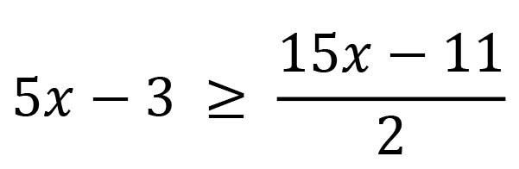

and
represent the answer on a number line.
b

Given that

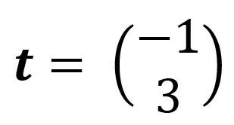

and

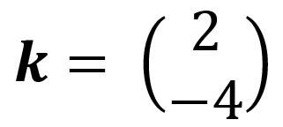

,
find 2t + k
c

The sides of a triangle are in the ratio 6: 8 : 10. If the perimeter of the triangle is 288 cm, find the:
i)

longest side
ii)

shortest side
iii)

difference between the longest and shortest sides.

2.
a

An English textbook costs GH₵ 25.00. The author of the book agreed to take 20% of the cost of each book sold. If 1,702 copies were sold, calculate the author's share.
b

Simplify:

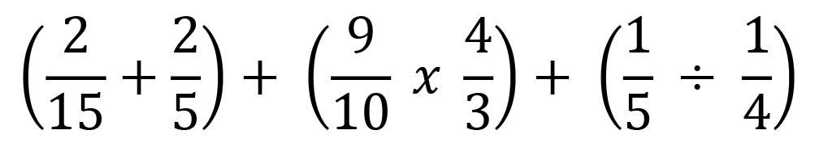
c

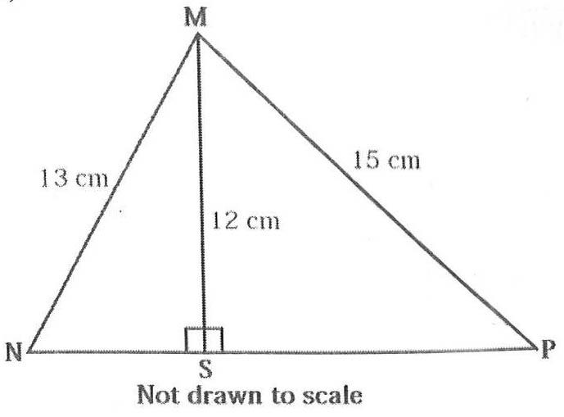
In the diagram, MN = 13 cm, MP = 15 cm, MS = 12 cm and MS is perpendicular to NP.
Calculate length NP.

3.
a

Simplify

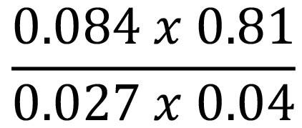

, leaving the answer in standard form.
b

i)

Make r the subject of the relation

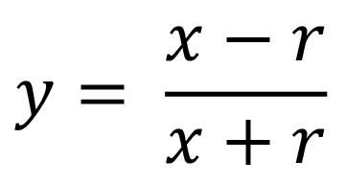
ii)

From (b)(i), find the value of r when y = 3 and x = 10.
c

Juliet bought 1,756 kg of frozen chicken, 675 g of vegetables and 95 g of corn oil from a Shopping Mall. What is the total weight of the items she bought in kilogram?

4.
a

The sum of the interior angles of a regular polygon is 900º. Find the number of sides of the polygon.
b

Using a ruler and a pair of compasses only, construct:
i

triangle XYZ such that length XY = 10 cm, angle XYZ = 30º and length YZ = 9 cm;
ii

perpendicular from Z to meet line XY at P;
iii

measure the:
α

length PZ;
β

angle XYZ.
iv

calculate, correct to the nearest whole number, the area of triangle XYZ.

5.
a

A property worth GH₵ 10,480.00 is shared between a widow and her 10 children in the ratio 1:4 respectively. The children shared their portion equally. Find each child's share.
b

The data shows the distribution of marks in a class test.
27 | 55 | 19 | 65 | 69 | 46
38 | 42 | 14 | 57 | 11 | 13
14 | 67 | 22 | 10 | 25 | 17
45 | 39 | 61 | 52 | 43 | 24
28 | 63 | 56 | 49 | 64 | 32
Use the data to answer the following questions:
i

make a Stem and Leaf plot of the data;
ii

how many students scored more than 10 marks and less than 20 marks?
iii

what is the probability of a student scoring less than 20 marks?

6.
a

An aeroplane left the Kotoka International Airport on Wednesday at 7:26 pm and reached its destination after nine hours thirty minutes. Find the day and the time the aeroplane reached its destination.
b

i

Using a scale of 2 cm to 2 units on both axes, draw two perpendicular axes 0x and 0y on a graph sheet for -10 ≤ x ≤ 10 and -12 ≤ y ≤ 12.
ii

Draw on this graph indicating the coordinates of all vertices, the quadrilateral ABCD with vertices A(0,10),B(-6,-2),C(-3,-11) and D(4,3).
iii

Draw the line x = -2 to meet AB at P and CD at Q.
iv

Measure angles BPQ and PQD.
v

State the relationship between:
α

angles BPQ and PQD;
β

lines AB and CD.

